Step1: To start the lab session, choose **Start Lab** in the upper-right corner of the page.

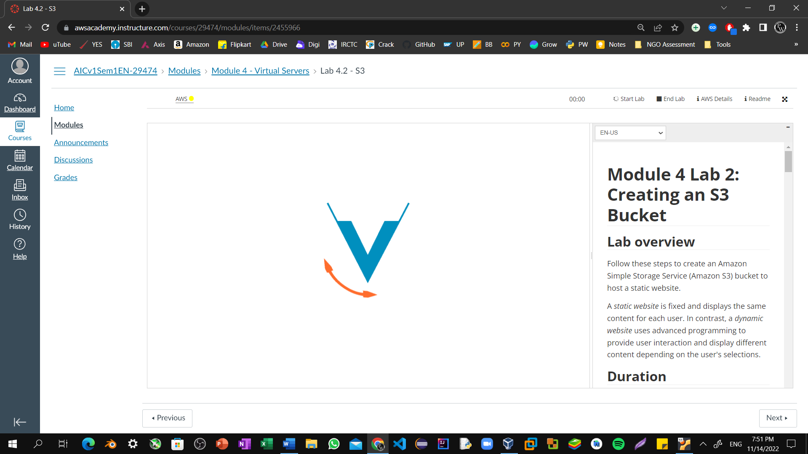

Step2: Choose the **Services** menu, locate the **Storage** services, and select **S3**.

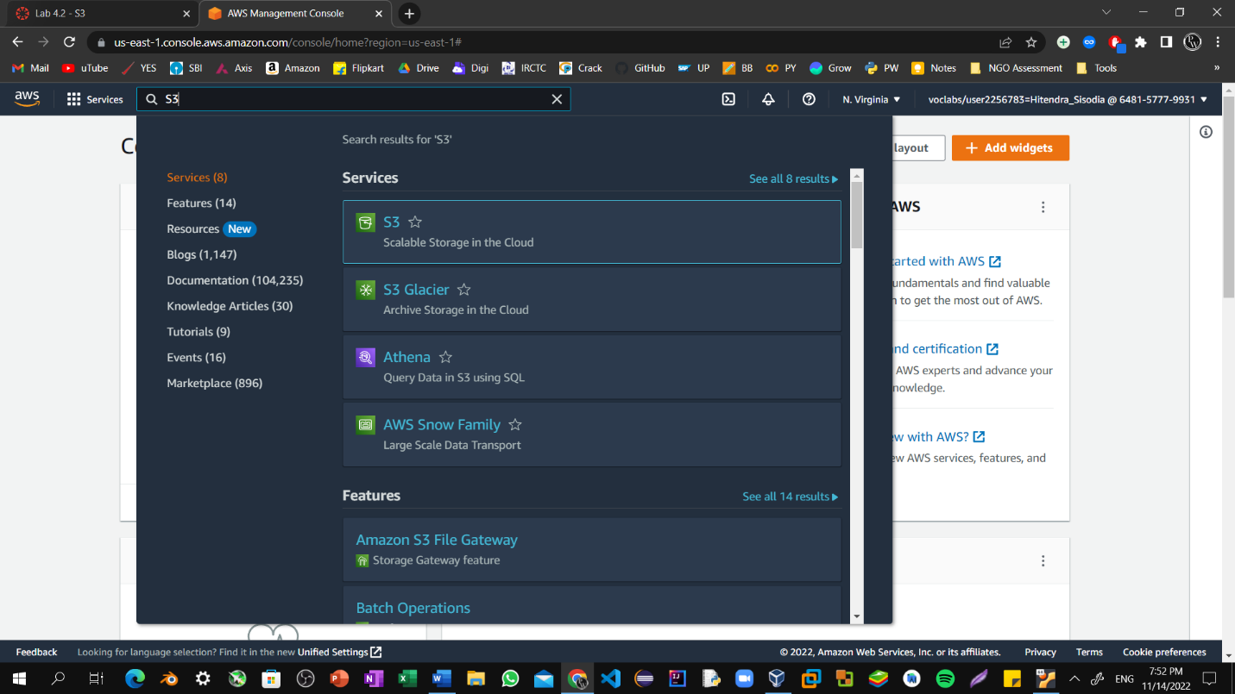

Step3: Select **Create bucket** on the right side of the page.

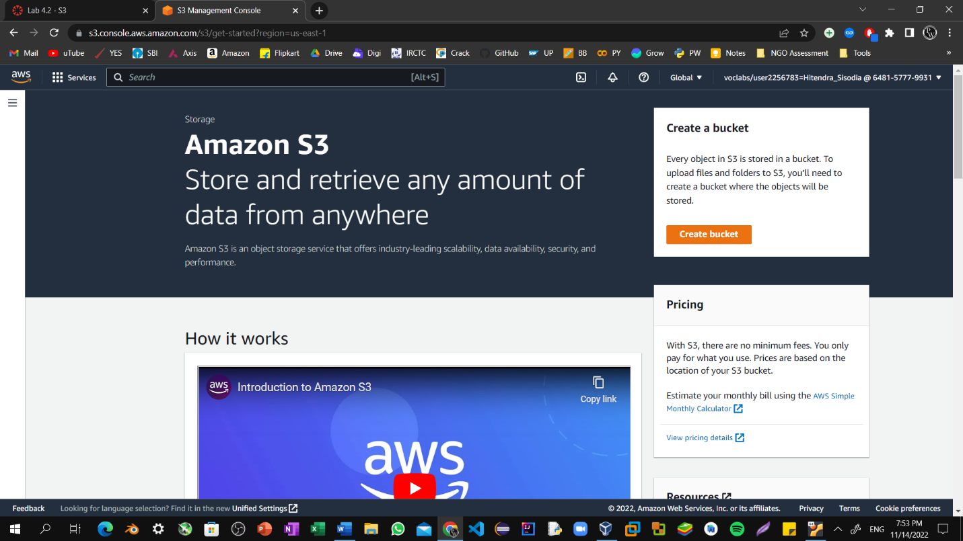

Step4: For **Bucket name**, enter a unique Domain Name System (DNS)-compliant name for your new bucket.

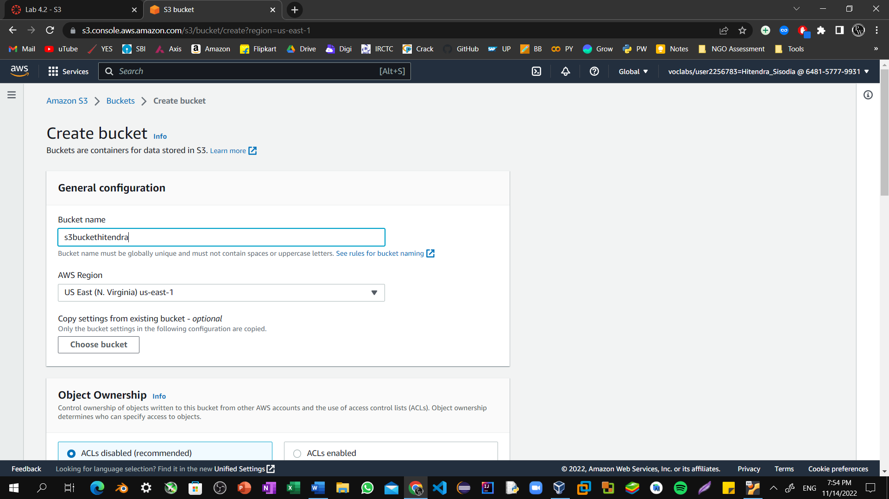

Step5: For **Region**, choose the AWS Region where you want the bucket to reside.

Choose a Region close to you to minimize latency and costs, or to address regulatory requirements. Objects stored in a Region never leave that Region unless you explicitly transfer them to another Region.

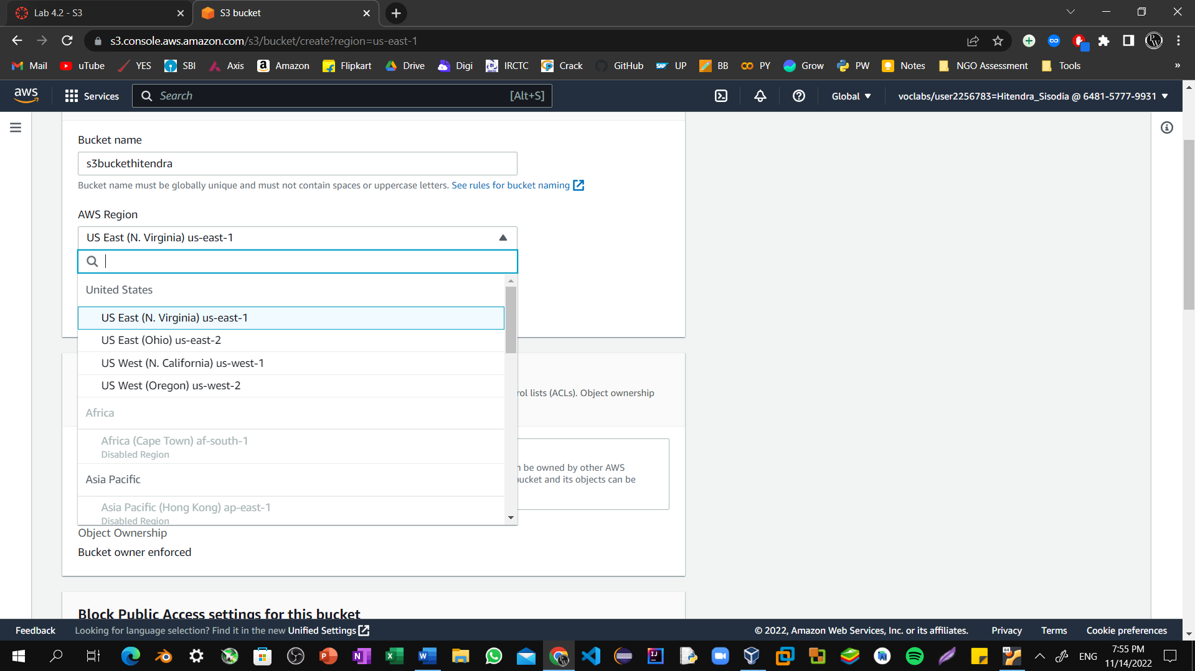

Step6: Uncheck the **Block all public access** box because you want to be able to test if the website is working.

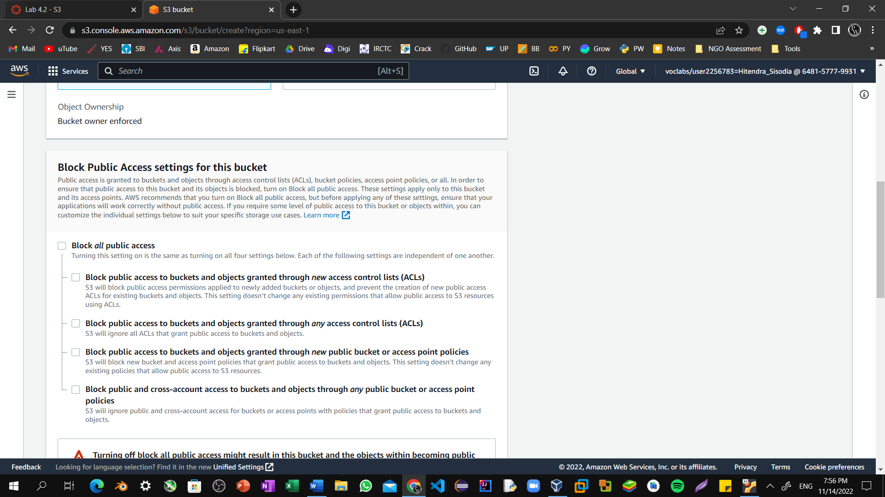

Step7: Below the warning, check the box next to **I acknowledge that...**.

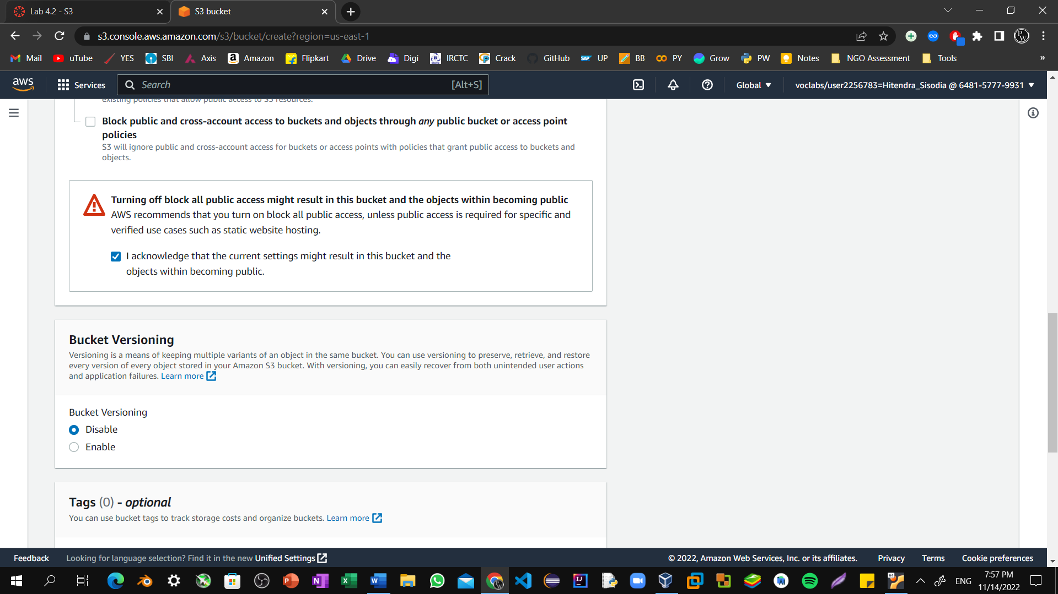

Step8: Scroll to the bottom of the page, and select **Create bucket**.

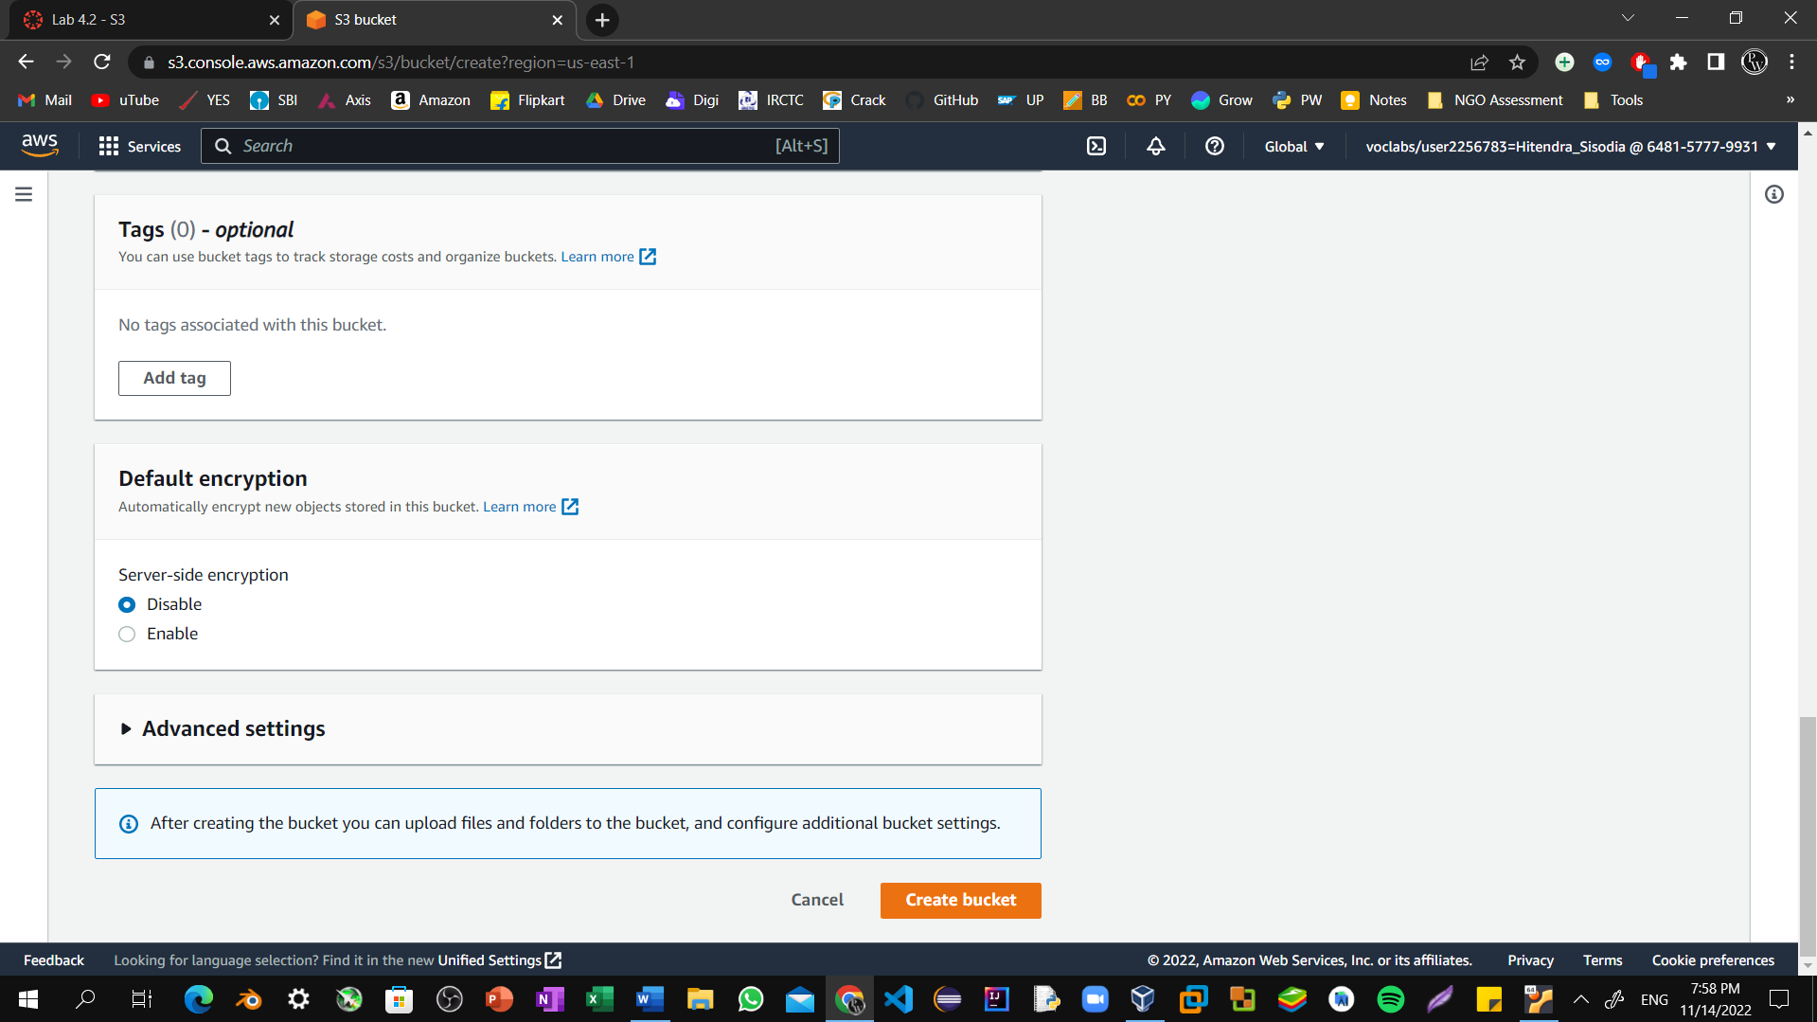

Step9: Successfully created Bucket.

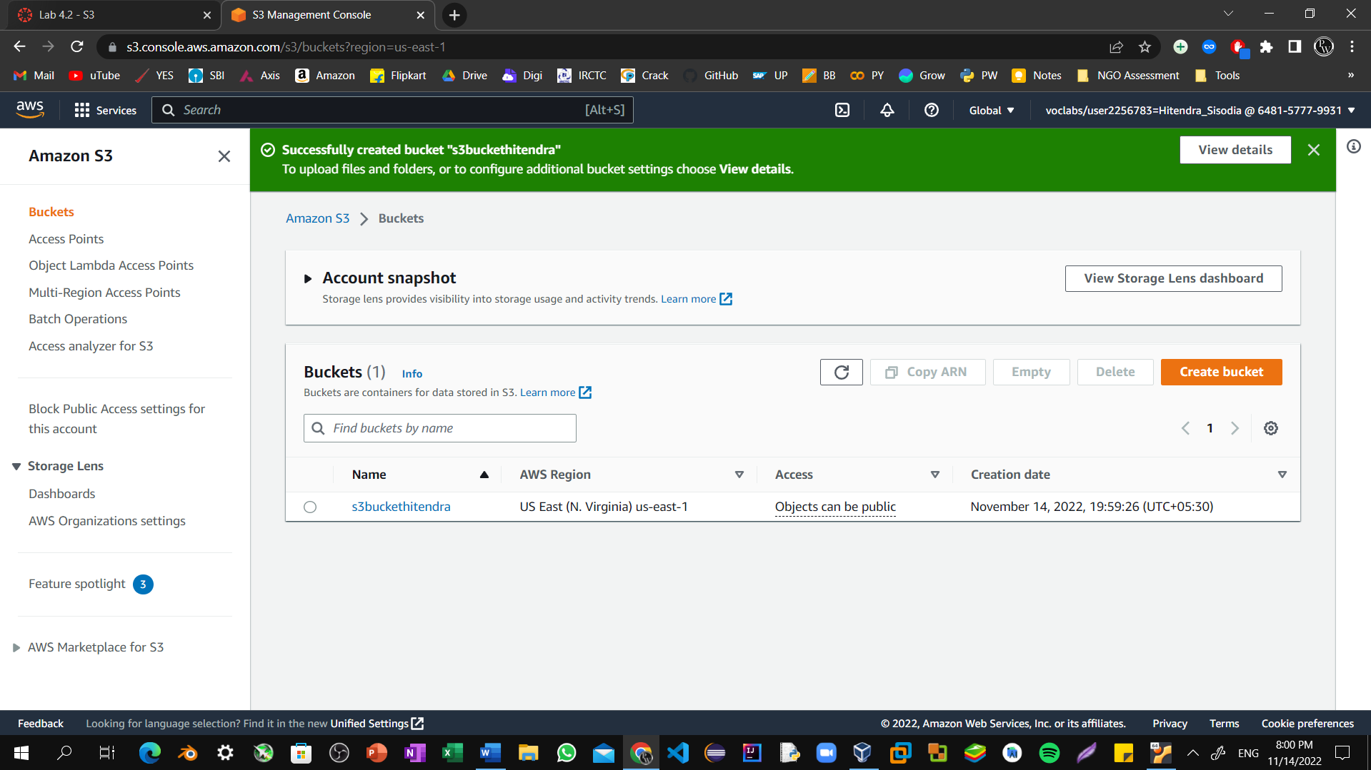

Step10: Choose the link for your bucket's name, and then select the permission tab.

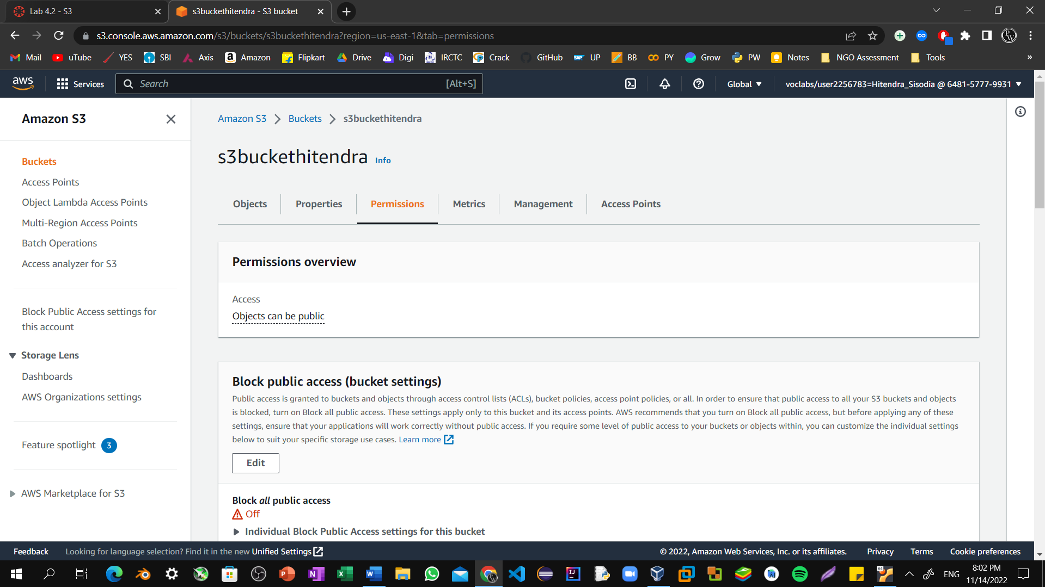

Step11: In the **Bucket policy** section, choose **Edit**.

To grant public read access for your website, copy the following bucket policy, and paste it in the policy editor.

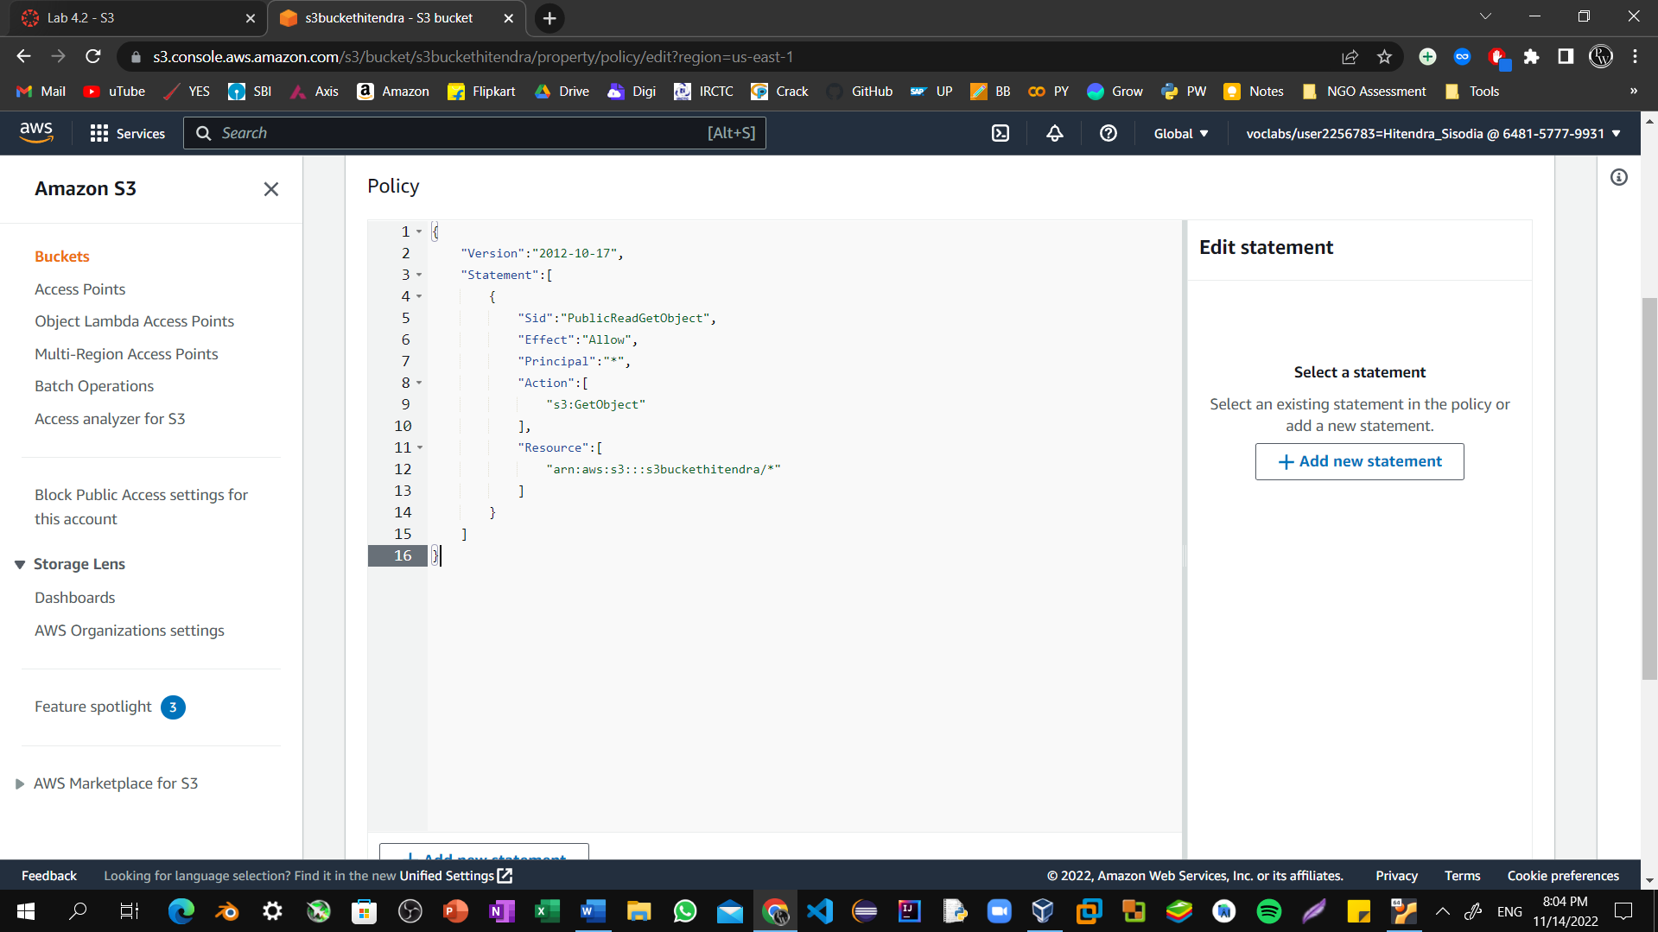

Step12: In the policy, replace **example-bucket** with the name of your bucket.

Select **Save changes**.

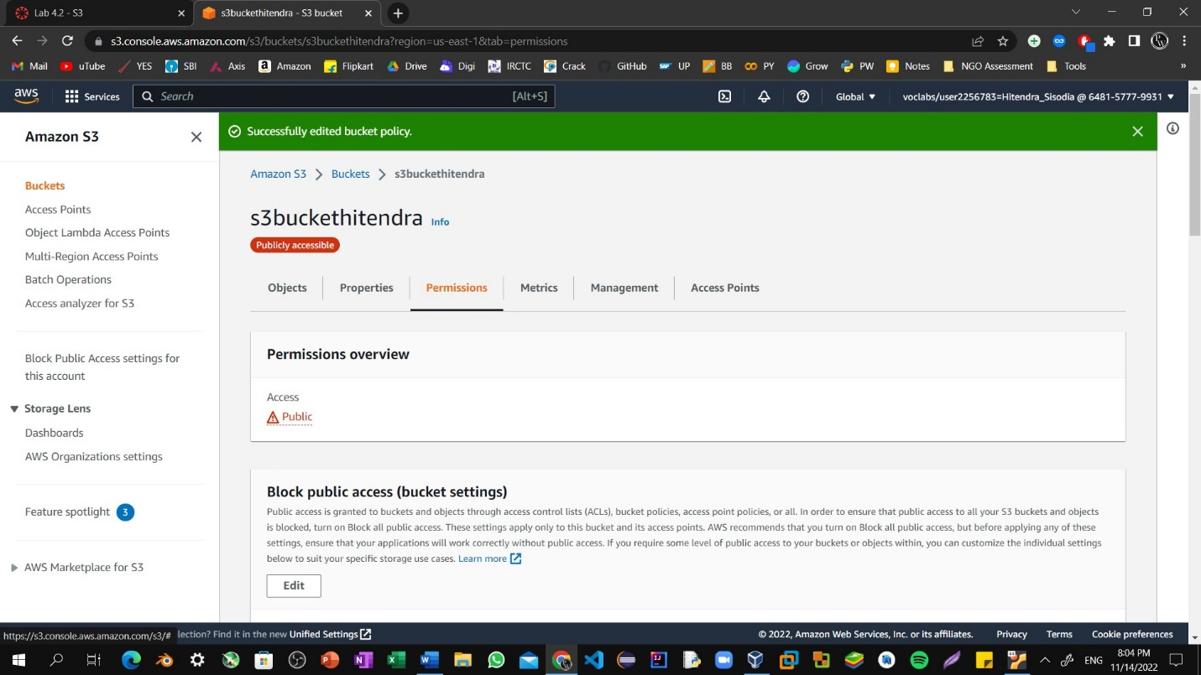

Step13: Open the context menu (right-click) for the following link, and then choose **Save link as**: [index.html](https://aws-tc-largeobjects.s3-us-west-2.amazonaws.com/CUR-TF-100-ACCAIC-1/lab-02-s3/index.html)

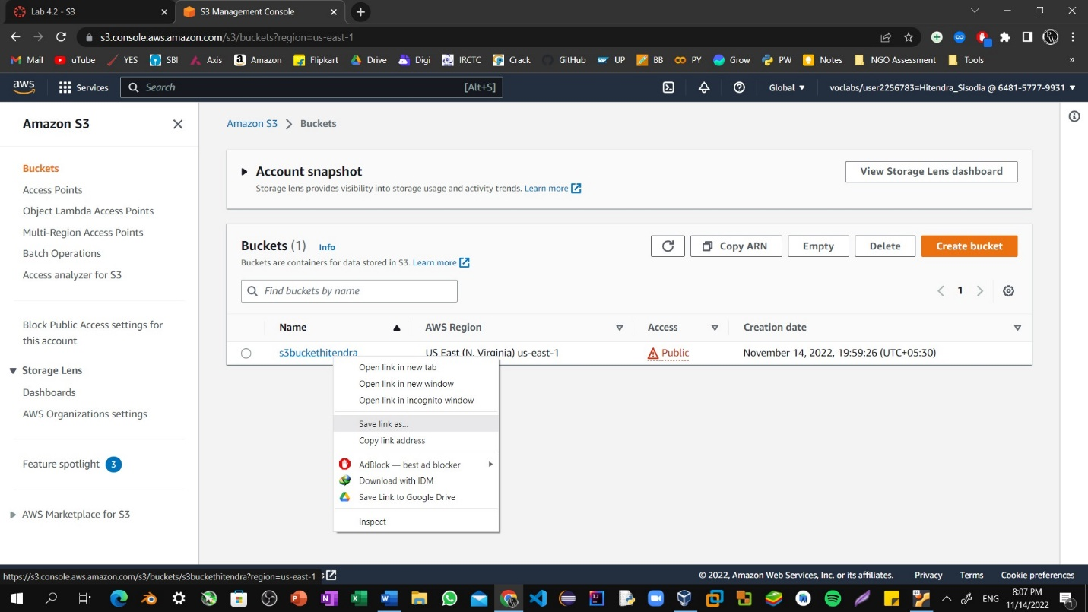

Step14: Save the index.html file to your local computer.

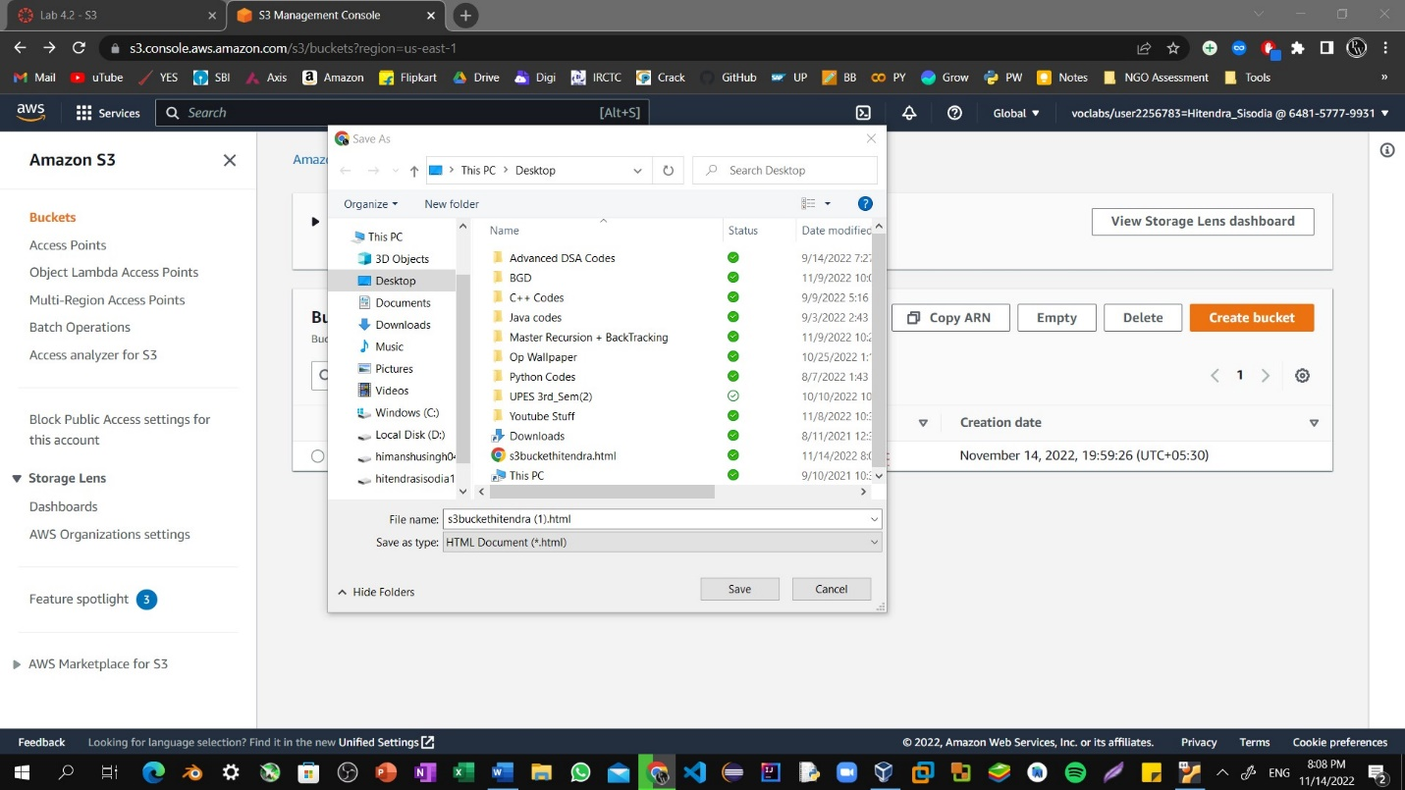

Step15: In the console, choose the **Objects** tab.

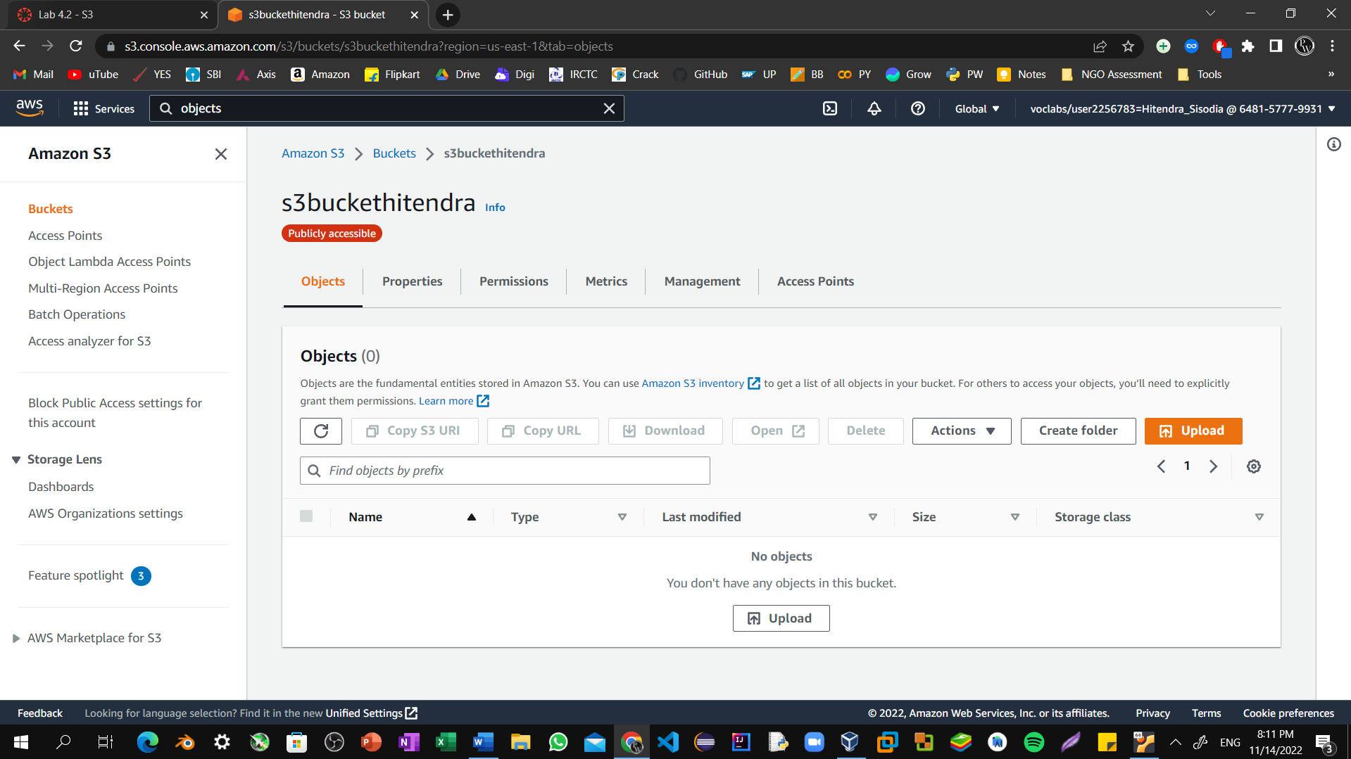

Step16: Upload the index.html file to your bucket.

Choose **Upload**.

Drag and drop the index.html file onto the upload page.

As an alternative, choose **Add files**, navigate to the file, and choose **Open**.

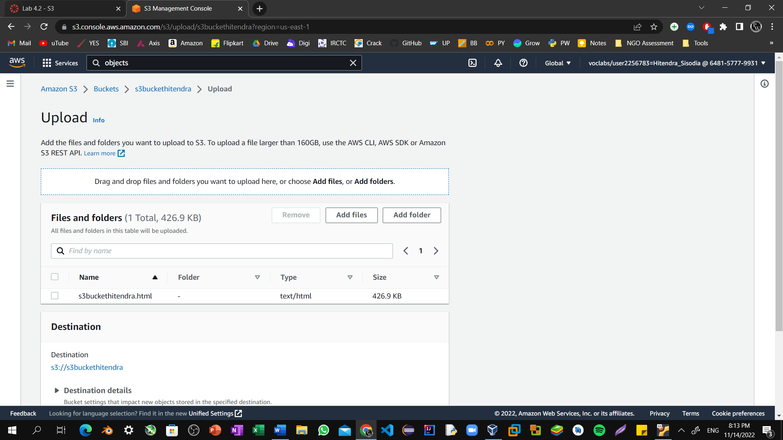

Step17: Expand the **Permissions** section.

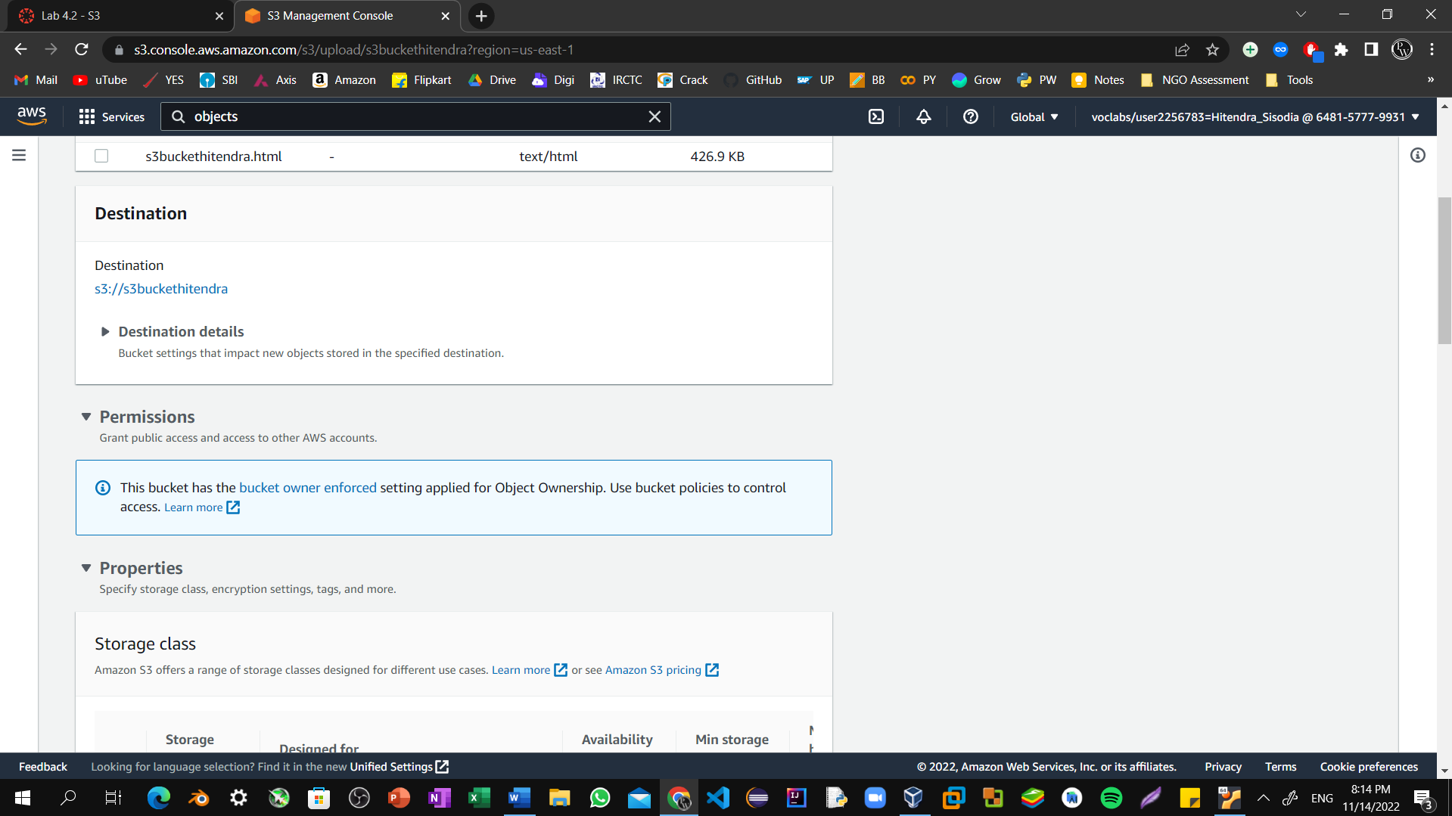

Step18: Under **Predefined ACLs**, select **Grant public-read access**. A warning message similar to **Granting public-read access is not recommend** appears below the setting you selected.

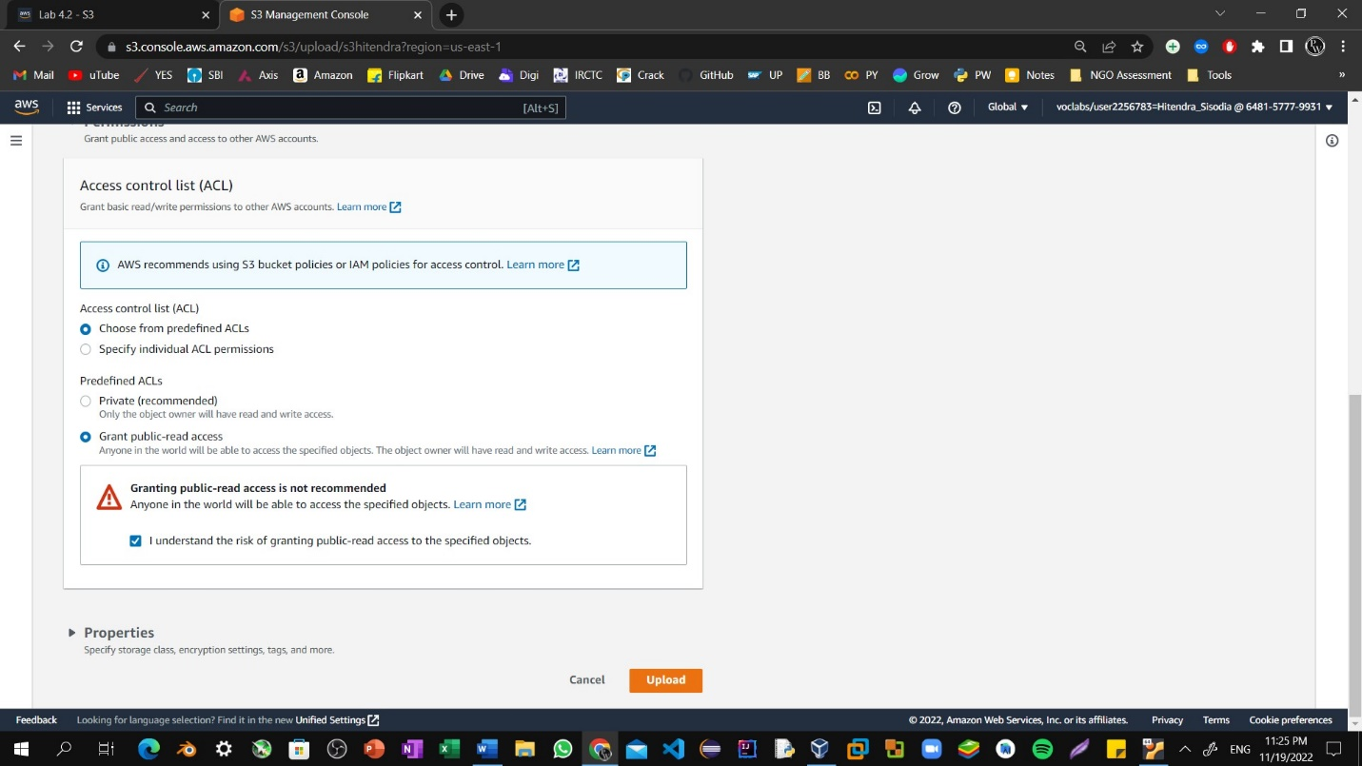

Step19: Expand the **Properties** section. Ensure that the **Standard** storage class is selected.

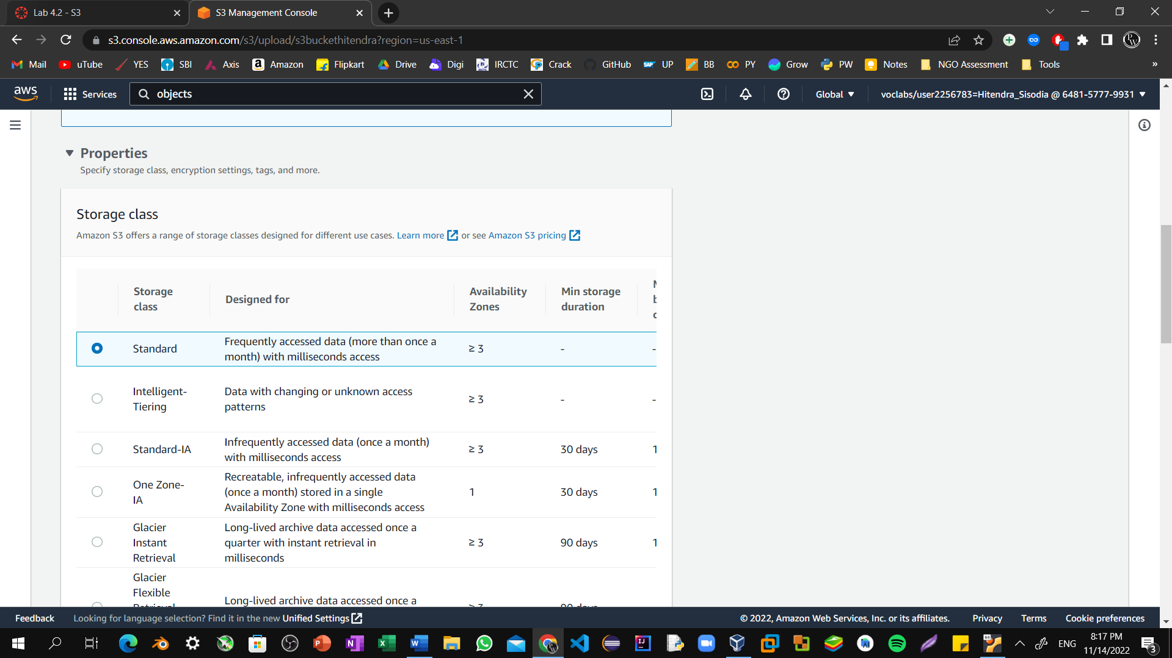

Step20: At the bottom of the page, choose **Upload**.

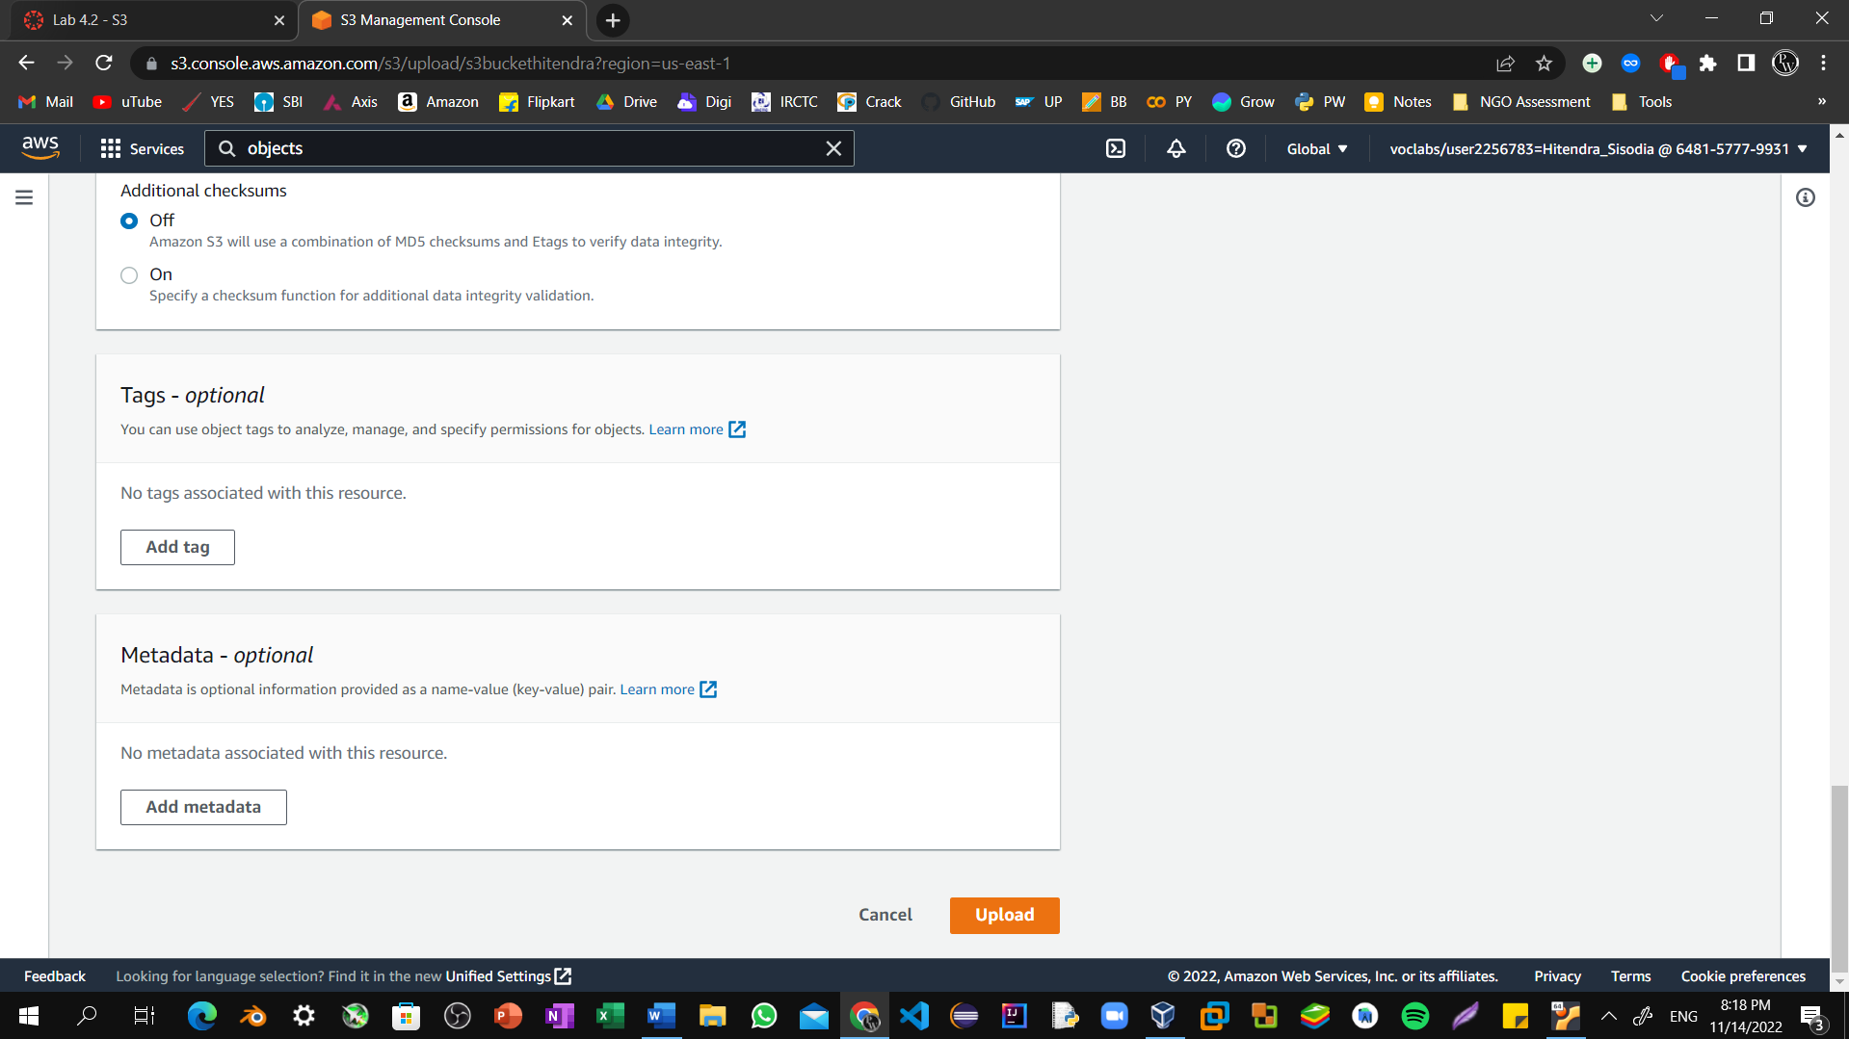

Step21: Choose **Close**. The index.html file appears in the **Objects** list.

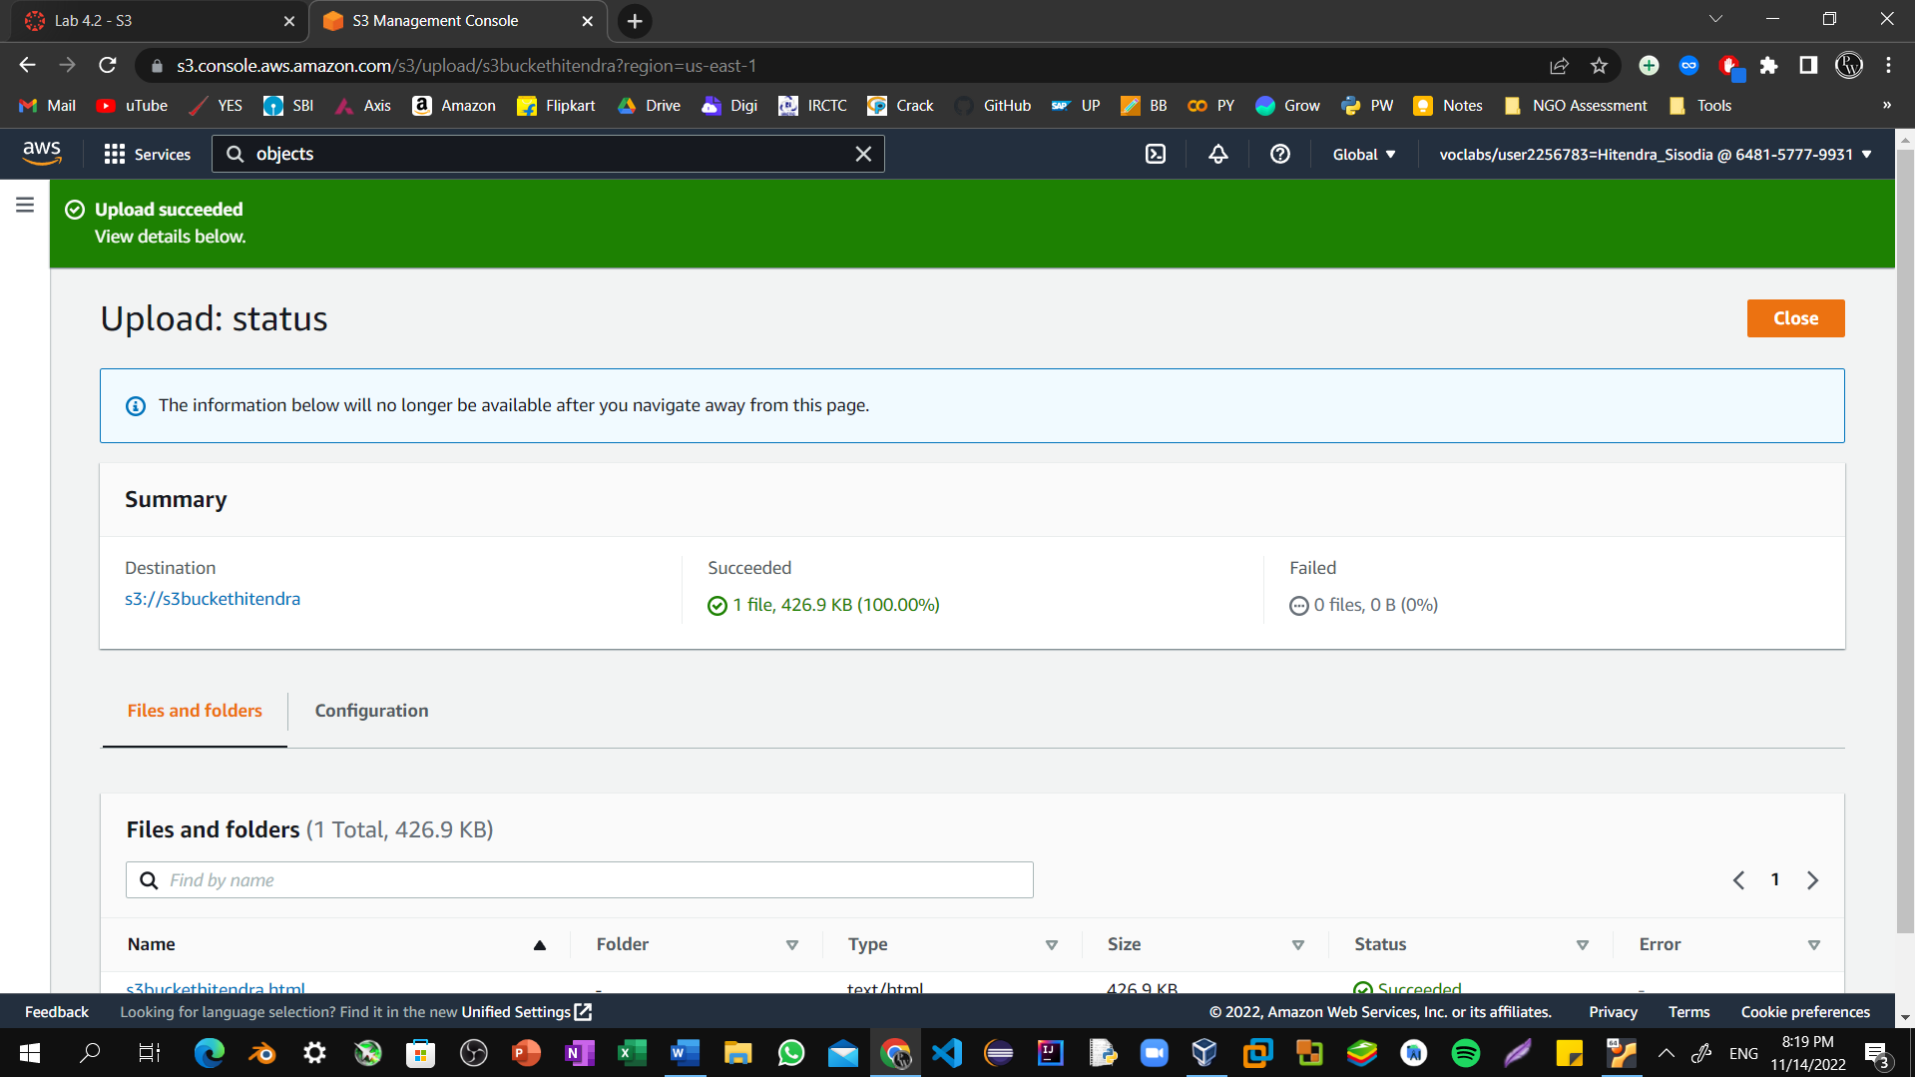

Step22: Select the **Properties** tab, and scroll down to the **Static website hosting** section. Choose Edit, Select Enable

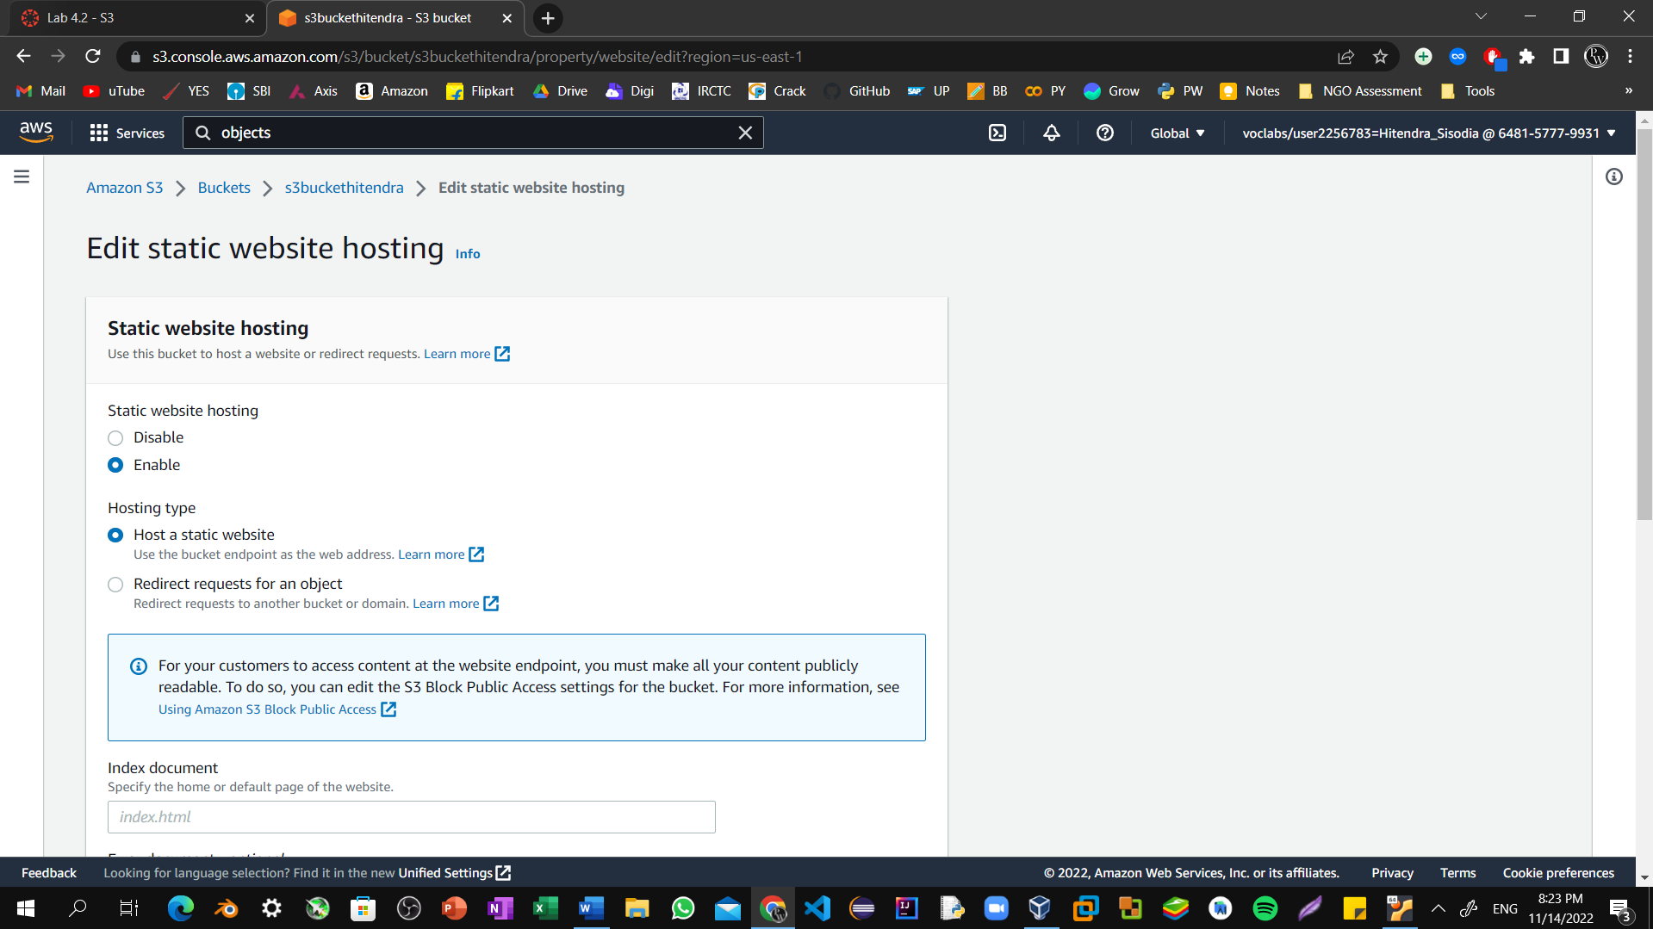

Step23: In the **Index document** text box, enter bucket-name.html Select **Save changes**.

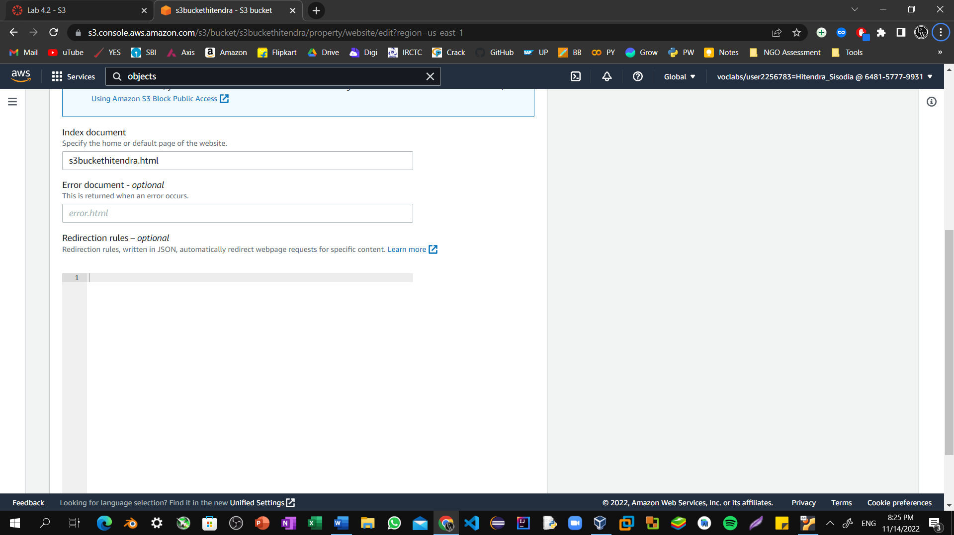

Step24: Scroll down to the **Static website hosting** section again, and copy the **Bucket website endpoint** URL to your clipboard.

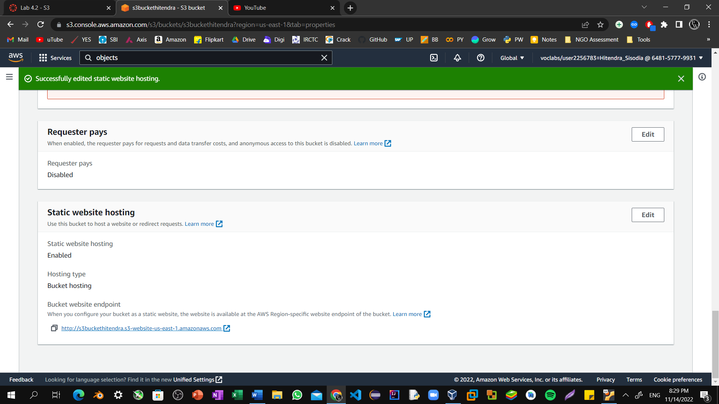

Step24: Static hosted website with EBS storage.

